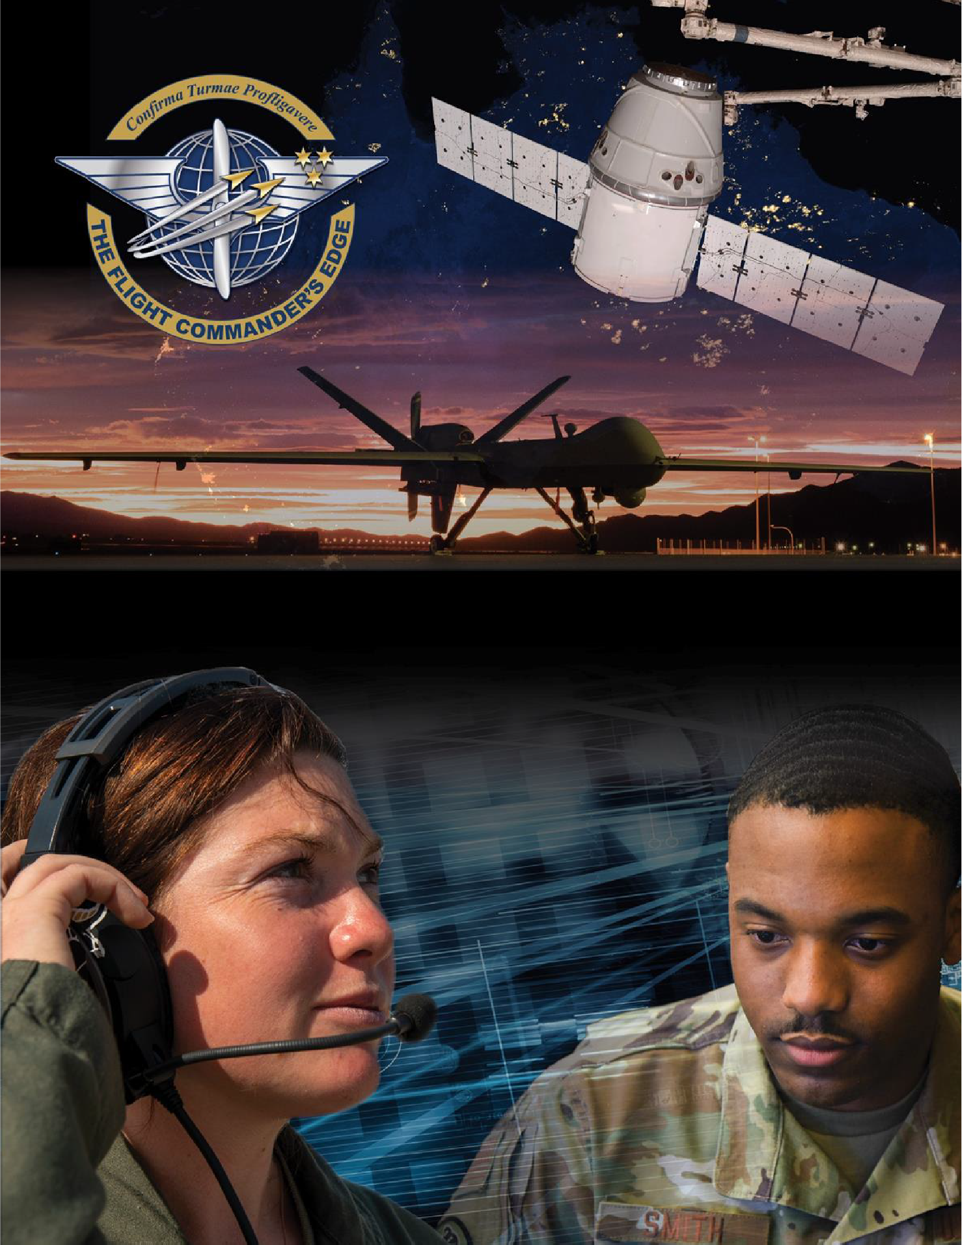

Lesson Plan

Ethical Leadership

#### 8 April 2025

## Table of Contents

About the Lesson 3

Before the Lesson 4

Presenting the Lesson 4

Appendix: Required Materials and Handouts 11

## How to Use this Lesson Plan

This lesson plan is divided into three key sections and an appendix containing supporting material.

The **About the Lesson** section outlines the lesson and identifies requirements for its effective use. Course Directors should use this section to (a) understand the purpose and context of the lesson, (b) learn about lesson pre-requisites, and (c) guide the selection of facilitators.

The **Before the Lesson** section provides details on the preparation required for this lesson, including student prerequisites (if any), recommended facilitator pre-course readings, and guidance on how to prepare the classroom.

The **Presenting the Lesson** section contains the actual lesson plan. It provides the recommended outline, discussion, and slide prompts along with actual *questions* and *recommended language* for the facilitator to use in the classroom.

The **Appendix** includes any required in-class handouts or exercise material.

For more information on how lessons are structured, or how to use them in the course, see the

###### Course Director’s Handbook or Facilitator’s Resources.

## Contact Us

Email: [flightcommandersedge@us.af.mil](mailto:flightcommandersedge@us.af.mil)

Website: <https://www.airuniversity.af.edu/GCPME/Flight-Commanders-Edge/>

# About the Lesson

## Ethical Leadership

## Overview

One of the hallmarks of command is to lead ethically. This entails understanding how new duties intersect with new authority and how ethical considerations permeate flight commander decision-making. Specifically targeted for developing a thoughtful ethical mindset as part of preparing for flight command, *Ethical Leadership* may be one of the most important lessons in this series.

## Objectives

By the end of this lesson, participants will:

1. Predict how ethical considerations will impact decision making as a flight commander.
2. Identify potential ethical challenges in an organization.
3. Demonstrate an ethical mindset.

## Recommended Prerequisites

* None

## Recommended Time

* 50 minutes

## Recommended Facilitator Qualifications

This lesson is designed for a facilitator with the following minimum qualifications:

1. Subject matter knowledge
2. Command-level experience

Note: Subject matter knowledge can be developed using the information presented in

**Preparing the Facilitator** section of this document.

# Before the Lesson

## Preparing the Participant

* None. There is no pre-work for this lesson.

## Preparing the Facilitator

All required materials and participant preparation, plus:

* Charles R. Myers, "The Core Values: Framing and Resolving Ethical Issues for the Air Force," *Airpower Journal* 11, no. 1 (Spring 1997): 39-52.
  + Available within the lesson area on *The Flight Commander’s Edge* website.
* Department of the Air Force, *A Profession of Arms*: *Our Core Values,* "The Blue Book."
  + A copy is available on the [Air University Foundational Resources](https://www.airuniversity.af.edu/Foundational-Resources/) homepage. Navigate to the link and click the “Blue Book” icon.

(Optional) Additional deep-dive preparation materials are available on *The Flight Commander’s Edge* website.

## Preparing the Classroom

* Adequate classroom space for separate small group discussions.
* White boards or easels with butcher block paper (one per group).
* Computer and projector with internet connectivity (no internet access required)

**Note:** Discussing ethics can be very personal and discussing ethical issues can be difficult for some. Facilitators need to be prepared to ensure a good classroom environment and remind participants to respect one another.

## Preparing Required Materials

Prepare one copy (per pairs) of the first handout. Each participant will need a copy of the second. Do not distribute handouts before the class.

* Global College of PME, *Preparing for Ethical Considerations of Command Worksheet*
* Global College of PME, *Ethical Leadership Self-Assessment Worksheet* Handouts are available in the Appendix.

# Presenting the Lesson

***NOTE:*** *This lesson is designed for the participants to have one-on-one discussions, in addition to small group discussions. Small groups should be no larger than five (5) members to maximize participation during small group discussion.*

## Introduction (5 minutes)

The introduction to the lesson sets the stage for future learning through a discussion of the new duties and responsibilities and “ethical considerations” of flight command, and the impact these new challenges may present. The focus is “What are the ethical issues that lay ahead as a flight commander?”

### Slide 1: Ethical Leadership

Introduce the lesson.

##### General Norman Schwarzkopf once noted that leaders are more likely to fail due to lack of *character* than a lack of competence. As leadership, ultimately, involves the effective exercise of influence, a lesson on the ethics of leadership is important for flight commanders. Because, now that you are a flight-level leader, you will experience ethical challenges.

### Slide 2: Objectives

This slide lists the lesson objectives.

After participants have reviewed the lesson objectives, continue.

### Slide 3: Small Group Discussion

Divide the participants into small groups (4 or 5 members) and prompt the participants with the following experience.

##### In your small groups, take five (5) minutes to talk about the kinds of ethical issues and problems you may face as a flight commander. Also, consider the types of ethical decisions you may be asked to make. But first, define “ethics.”

##### At the end of the discussion, be prepared to answer the following questions regarding ethical decision making:

##### What is “ethics”? What are “ethics”?

##### How will the ethical decisions you make change now that you are a flight- level leader?

##### Jot down your thoughts and be prepared to present your answers at the end of the discussion.

Monitor participants’ discussions for activity. After five (5) minutes, continue.

## Initial Discussion (10 minutes)

The initial discussion builds on the small group discussion in the introduction and stresses the differences in the flight-level leader environment – how flight commanders will need to

think through decisions to be made – from an ethical standpoint. These key concepts inform the rest of the lesson.

### Slide 4: Large Group Discussion

Reconvene the large group and ask one member from each group to share their group’s answer. Ask:

##### What did you decide “ethics” means?

##### What will change now that you are a flight-level leader?

Record key points from answers on a whiteboard.

**Anticipated Responses:** Answers will vary but should focus on the increased self- awareness of ethical decisions to be made. Note any comments of new duties and new responsibilities. Are these looked at through an *ethical leadership* lens? You will reference these items during the content presentation. (Use of actual terms is not necessary).

* Merriam-Webster dictionary defines ethics as “moral principles that govern a person’s behavior or the conducting of an activity”
* Ethics in plural form: the discipline dealing with what is good and bad and with moral duty and obligation
* A set of moral principles
* A guiding philosophy
* Ethics refers more broadly to moral principles
* Can be seen applying it (ethics) to questions of correct behavior and universal fairness

After a brief discussion, continue.

## Content Presentation (5 minutes)

This section of the presentation bridges between the discussion above on the ethical issues and problems that might be faced by a flight commander and the forth coming activity where

participants pair up and conduct a mock interview. Participants’ understanding of the terms “ethical dilemma” and “ethical leadership” will help them to identify potential ethical challenges, discussed during their mock interviews.

### Slide 5: Key Ethical Leadership Concepts

##### As your small group discussions highlighted, it appears all of us encounter challenges in our lives. Sometimes they are quickly or easily resolved, but other times, it is not clear what to do, and there is no right or wrong answer. This is a dilemma.

##### When we are faced with a dilemma, it is important to stop and consider our choices carefully and recognize how our values will influence our decision. We must also think about how our decisions will affect others. This is especially true as a flight-level leader.

##### Ethics, at its most basic level, is about the sense of right and wrong we have regarding our actions and their consequences.

##### Ethical Leadership is about applying this sense of right and wrong—your values and the *institution’s* values—to every day decision making.

### Slide 6: Five Principles of Ethical Leadership

##### The slide lists five principles associated with ethical leadership that can be traced back to Aristotle:

##### Respect Service Justice Honesty Community

##### These five principles are embedded in our Core Values and should drive the decisions you make as a flight-level leader. You must be “ethical” as you lead, and you must be mindful of the “*un*ethical” and avoid leading outside of your authority.

##### Keep these terms in mind as we do our next activity.

When complete, continue.

## Application Activity (25 minutes)

Up to this point, the lesson has focused on predicting duties and responsibilities and defining key ethical concepts. This part of the lesson builds on the previous class discussion but brings the topic of ethical leadership to a more personal level.

**Slide 7: Pair and Share *Considerations of Command* Interview Activity**

Divide the participants into pairs. There should be enough space between the pairs to have normal-tone conversations without overhearing the other discussions in the room.

Distribute the **Global College of PME, *Preparing for Ethical Considerations of Command Worksheet*** (2 pages) to the pairs (one set per pair).

When complete, continue.

Prompt the pairs with the following information to begin the activity.

##### This is a role play activity. One of you is the squadron commander welcoming a new flight commander.

##### In your pairs, take about ten (10) minutes to conduct the interview.

##### Following the mock interview, you will have time to do a reflection activity prior to sharing with the class.

Monitor pairs’ discussions for activity. They should have conversations following the provided interview prompts.

After no more than ten (10) minutes, encourage the interview sessions to conclude and move the pairs on to the reflection portion (page 2) of the activity.

##### Go ahead and take five (5) minutes to complete page two of the worksheet. We will come back together as a class and discuss the interview experience.

Monitor pairs’ discussions during the reflection portion as they (together) fill out their responses.

After five (5) minutes, continue.

### Slide 8: What Did You Learn? What Will You Share?

Reconvene the large group and ask members of the pairs to share from their key takeaway sheets (page 2 of their handout). Take no more than 10 minutes and ask the following

##### What are some of the ethical challenges of flight commander duties and what happens if not carried out ethically?

**Anticipated Responses:** Vary but should focus on the following.

|  |  |
| --- | --- |
| **Some ethical challenges of FC duties** | **What happens if not carried out ethically** |
| Transparency / Accountability (Example: managing money) | Can result in legal actions and loss of trust |
| Enforcing policies fairly | Can adversely affect or erode morale, good order, and discipline |
| Not showing favoritism | Can adversely affect unit cohesion |
| Completing fair and accurate personnel evaluations | Can undermine morale and corrode the respect for chain of command |
| Speaking truthfully and honestly | Can result in lack of trust and confidence |
| Willing to have hard conversations | Can be considered unprofessional |

##### How will you ensure you will be a consistent ethical leader?

**Anticipated Responses:** Vary but should focus on the following.

|  |  |
| --- | --- |
| **How will you be consistent ethical**  **leader** | **What happens if you don’t lead ethically** |
| Demonstrate respect | Erodes trust and confidence in my leadership as Flt/CC |
| Demonstrate honesty | Sets bad example for others in my flight |
| Not showing favoritism | Can adversely affect unit cohesion |
| Practice highest standards of conduct and integrity | My behavior and decisions can affect other people’s lives and careers |
| Maintain professional relationships | SQ/CC could face penalties for Flt/CC ethical misconduct |

At the end of the large group, summarize this was an opportunity to practice an ethical conversation and, in addition, highlight that participants can expand their own personal definition of ethical leadership based on this interview activity.

## Lesson Wrap-Up (5 minutes)

The final lesson activity is a self-assessment of ethical decision-making behaviors used by flight commanders. This activity feeds the final lesson in the course – *The Road Ahead* – and will be used to support the development of the participants’ personal development plan.

Distribute the **Global College of PME, *Ethical Leadership Self-Assessment Worksheet*** to all participants.

When complete, continue.

### Slide 9: Leading Ethically Self-Assessment

Initiate the self-assessment and wrap up the lesson.

##### In this lesson, we’ve looked at how, as a flight-level leader, you need to understand potential ethical challenges to help you think through your ethical decision making. You’ve even had an opportunity to have a—pretend— conversation with a squadron commander over the ethical challenges in an organization.

##### Now, it’s time to take a moment to reflect on some of the ethical principles of leadership. This self-assessment is designed to prepare you to have an actual conversation with your squadron commander over the challenges of leading ethically.

##### The *Ethical Leadership Self-Assessment Worksheet* is designed to help you plan for your future. The instructions are self-explanatory. Take a moment to read them, then fill out the sheet. If you need more time, you can go into the break.

##### Keep this worksheet for reference. You will need it again for the last lesson of the course.

End. Break (10 minutes).

# Appendix: Required Materials and Handouts

The materials required for this lesson include:

* Global College of PME, *Preparing for Ethical Considerations of Command Worksheet*
* Global College of PME, *Ethical Leadership Self-Assessment Worksheet*

These handouts, on the following pages, are designed for printing directly from the lesson plan. Ensure you print enough copies for all class participants.

## Preparing for Ethical Considerations of Command Worksheet

*Developed by the Global College of PME*

### Directions

One participant takes on the role and thinking of the **squadron commander,** who fills out the notetaker; the second participant is a newly hired **flight commander** in the squadron.

The squadron commander is interviewing the flight commander prior to the first day on the job and will take notes of the flight commander responses.

Keep these “roles” until the interview ends. Then reflect on the conversation you just had; together, complete the blocks on the second page with elements you will share with the class.

|  |  |
| --- | --- |
| **Squadron Commander** | **Flight Commander responses** |
| Capt X, congratulations on being selected as a flight commander.  Describe some of the new duties and responsibilities that you THINK you will be taking on.  [*What is the perception of this role*] |  |
| Sounds like you have a pretty good grasp of some of the things you’ll be taking on. You might also be doing other things like…. (fill in blank if the Sq/ CC thinks of something the Flt/CC missed). |  |
| Thinking about those new responsibilities, talk to me about the **ethical requirements** of carrying out those duties and where some ethical challenges may be. |  |
| Glad to hear that you are thinking about these things. Some other things you might want to consider are… (fill in the blank if the Sq/CC thinks of something the Flt/CC missed.” |  |
| Let’s talk about some of the consequences to you, your members, and the unit if you don’t carry out your duties ethically. |  |
| **Things for us to discuss:** What areas do you think will be the most challenging, **ethically,** for you? What are some specific things you can do to ensure you are a consistent ethical leader, especially in  the areas you think will be challenging for you? | |

Fill out together, at the end of the class-paired commander interview conversation in preparation for sharing with the class.

|  |  |
| --- | --- |
| **Prompt** | **Key take aways—our thoughts—what we will share** |
| What are the *ethical challenges* of flight commander duties? What happens if duties aren’t carried out ethically? |  |
| What areas will be most challenging, ethically, for you? |  |
| What are some things you can do to ensure you are a *consistent* ethical leader, especially in the areas you think that will be challenging for you? |  |
| **Additional considerations:** | |

NOTE: One copy of this two-page handout is needed per pair conducting the role-play.

## Ethical Leadership Self-Assessment Worksheet

This self-assessment provides an opportunity for you to reflect on your ethical leadership. These ethical leadership principles are based upon the concepts addressed within this lesson. *You will use these worksheets again during the final lesson of the course.*

Using the five principles associated with ethical leadership (traced back to Aristotle) write five sentences regarding your ethical leadership and how you will demonstrate an ethical mindset as a flight commander.

|  |
| --- |
| **My Personal Development Plan – How Will I Demonstrate an Ethical Mindset?** |
| Include these statements with your Professional Development Plan:  **Respect** (How well do I treat others with respect?)  **Service** (How well do I serve others?)  **Justice** (How just am I?)  **Honesty** (How honest and authentic am I?)  **Community** (How will I influence my flight to achieve a common goal and build community?)  **My notes** |